
COMPUTATIONAL FLUID DYNAMICS AND CONJUGATE HEAT TRANSFER ANALYSIS REPORT
CAD Design and Numerical Simulation of a
Swirled Tube Heat Exchanger
Turbulent Nonisothermal Flow Simulation with a Hybrid Al₂O₃–CuO–CNT Nanofluid Coolant Using the k–ε Turbulence Model
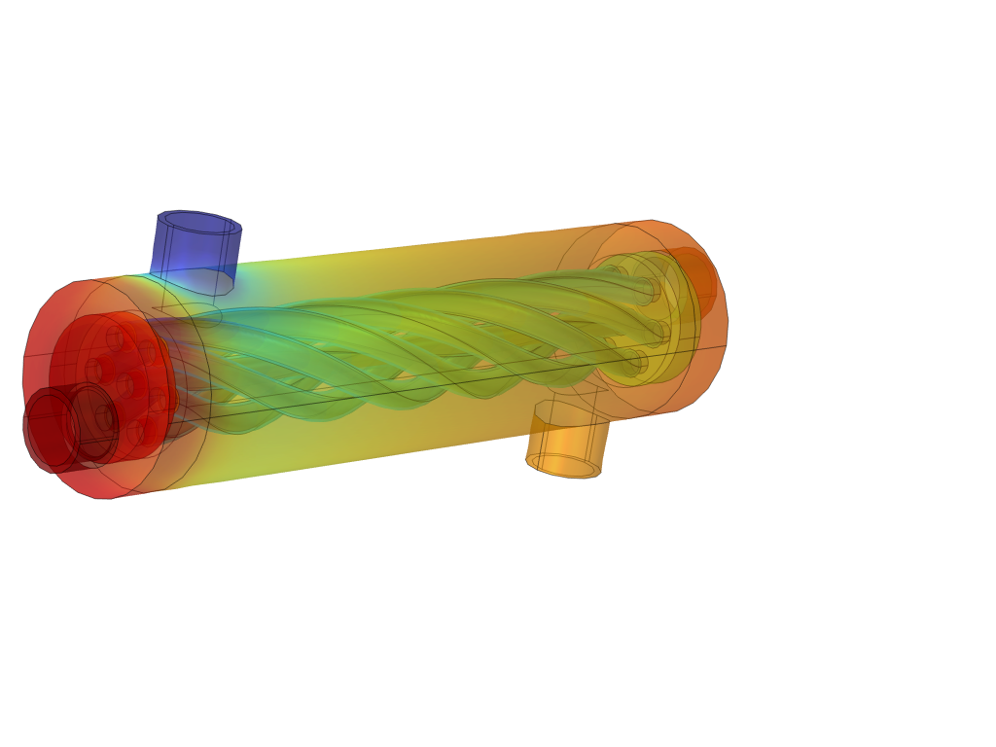
Figure 0.1 Imported CAD assembly of the swirled tube heat exchanger, coloured by the resulting temperature field
Prepared for: Simulation and Design Review
Author: Frais Asghar
Simulation Platform: COMSOL Multiphysics (Heat Transfer Module, CFD Module)
Report Date: September 10, 2026

Table of Contents
Table of Contents 2
Abstract: 3
1. Introduction 3
1.1 Background: 3
1.2 Objectives: 4
1.3 Scope of the Simulation: 4
2. CAD Geometry and Model Construction 4
2.1 Geometry Description 4
2.2 Geometry Statistics 5
2.3 Domain Assignment 6
3. Mathematical Formulation 6
3.1 Continuity Equation 6
3.2 Momentum Equation (Reynolds Averaged Navier–Stokes) 7
3.3 Turbulence Closure: Standard k–ε Model 7
3.4 Conjugate Energy Equation 7
3.5 Boundary Conditions 7
4. Materials and Thermophysical Properties 7
4.1 Operating Parameters 8
4.2 Solid Material Properties 8
4.3 Fluid Material Properties 8
5. Numerical Model Setup 9
5.1 Physics Interfaces 9
5.2 Boundary Conditions Summary 9
5.3 Mesh 9
5.4 Solver Configuration 10
6. Simulation Results 11
6.1 Temperature Field 11
6.2 Velocity Field 12
6.3 Pressure Field 13
6.4 Combined Nonisothermal Flow Visualisation 14
6.5 Extracted Boundary Values 14
7. Hand Calculated Thermal Performance 15
7.1 Mass Flow Rates 15
7.2 Heat Duty and Energy Balance 15
7.3 Log Mean Temperature Difference 15
7.4 Overall Thermal Conductance 15
7.5 Effectiveness and Number of Transfer Units (ε–NTU Method) Cross Check 16
7.6 Pressure Drop 16
7.7 Summary of Calculated Performance 17
8. Conclusion 17
References 18

Abstract:
This report presents a complete computer aided design and computational fluid dynamics study of a shell and tube heat exchanger fitted with a helically swirled inner tube. The unit was designed in SolidWorks and imported into COMSOL Multiphysics, where a three dimensional, steady state, conjugate heat transfer simulation was carried out using the turbulent k–ε model coupled with the Nonisothermal Flow multiphysics interface. A hybrid Al₂O₃–CuO–CNT nanofluid at 1.2 percent volumetric concentration was circulated as the hot working fluid through the swirled inner tube, while plain water was circulated as the cold fluid in the annular shell space, separated by a steel AISI 4340 tube wall and enclosed within an acrylic plastic shell.
The simulation solved the continuity, Reynolds Averaged Navier–Stokes, turbulence transport, and energy equations simultaneously across the solid and fluid domains, producing full three dimensional temperature, velocity, and pressure fields. The raw results extracted from the model, namely the inlet and outlet temperatures and pressures of both streams, are combined in this report with hand calculations of the heat duty, log mean temperature difference, overall thermal conductance, effectiveness, number of transfer units, and pressure drop for each circuit. The hot nanofluid stream is cooled from 65.0°C to 57.15°C while the cold water stream is heated from 25.4°C to 55.0°C, corresponding to an average recovered duty of approximately 4.24 kW and a heat exchanger effectiveness of approximately 77 percent. The results confirm that the internal helical swirl geometry, in combination with a nanofluid coolant of enhanced thermal conductivity, produces strong secondary flow mixing and a high rate of heat recovery for a compact exchanger volume.

1. Introduction

1.1 Background:
Shell and tube heat exchangers remain the most widely used class of industrial heat exchange equipment because of their mechanical robustness, ease of manufacture, and flexibility in duty. A well known limitation of the plain circular tube configuration, however, is the comparatively thin thermal boundary layer growth suppression that a straight, unobstructed bore provides, which keeps the convective heat transfer coefficient close to that of fully developed laminar or mildly turbulent pipe flow. A common passive augmentation technique is to twist or swirl the tube itself, or to insert a twisted tape or coil, so that the working fluid is forced into a helical secondary flow pattern. This secondary swirling motion continuously disrupts the growth of the thermal boundary layer, increases the radial mixing of hot and cold fluid parcels, and raises the internal convective heat transfer coefficient, generally at the cost of a moderate increase in frictional pressure drop.
A second, complementary augmentation strategy that has attracted extensive research interest over the last two decades is the use of nanofluids, that is, base fluids seeded with a low volume fraction of nanometre scale solid particles of high thermal conductivity, such as metal oxides or carbon nanostructures. When two or more nanoparticle species are combined in a single base fluid, the resulting mixture is termed a hybrid nanofluid. Hybrid nanofluids are of particular interest because the properties of the constituent particles can, in principle, be combined synergistically, for example pairing the high thermal conductivity of a carbon nanotube with the chemical stability and low cost of a metal oxide such as aluminium oxide or copper oxide.
The present study combines both augmentation strategies in a single unit: an internally swirled tube geometry carrying a hybrid Al₂O₃–CuO–CNT nanofluid as the hot stream, exchanging heat with plain water as the cold stream across a steel tube wall.

1.2 Objectives:
- Reconstruct and present the CAD geometry of the swirled tube heat exchanger in a clear, documented form.
- Present the governing mathematical model used for the conjugate turbulent flow and heat transfer simulation, expressed in standard mathematical notation.
- Summarise the material properties, boundary conditions, mesh, and solver configuration used in the COMSOL Multiphysics model.
- Report and interpret the simulated temperature, velocity, and pressure fields with supporting figures.
- Use the extracted boundary values to hand calculate the remaining thermal performance parameters of the exchanger, namely the heat duty, log mean temperature difference, overall conductance, effectiveness, number of transfer units, and pressure drop, and cross check these results for internal consistency.

1.3 Scope of the Simulation:
The simulation is steady state and three dimensional. Turbulence is modelled using the standard k–ε model with wall functions, coupled to the temperature field through the Nonisothermal Flow multiphysics interface, which accounts for the temperature dependence of the fluid density, viscosity, thermal conductivity, and specific heat. The solid tube wall and shell are modelled as conjugate heat conducting domains, allowing heat to pass directly from the hot nanofluid, through the solid steel wall, into the cold water stream, without any assumed film or overall heat transfer coefficient being imposed a priori. All performance metrics reported here are therefore either direct outputs of the three dimensional field solution or are derived from those outputs using standard heat exchanger design relations.

2. CAD Geometry and Model Construction

2.1 Geometry Description
The heat exchanger geometry was constructed as a three dimensional assembly in SolidWorks and imported directly into COMSOL Multiphysics as a parasolid CAD file. The unit is a compact double pipe style shell and tube exchanger in which the inner tube follows a helical, swirled centreline rather than a straight axis, so that both the hot fluid travelling inside it and the cold fluid travelling around it in the annular shell space are forced into a continuously rotating secondary flow. The imported assembly was then reoriented within the COMSOL geometry sequence using a rotation of 90 degrees about the x axis and a translation, so that the flow axis of the exchanger is aligned with the global x direction, followed by a series of boolean difference, delete entities, adjacent selection, and union operations used to define the distinct fluid and solid domains and to tag the inlet, outlet, and interior wall boundaries required by the physics interfaces.
Overall, the finished geometry comprises twelve domains: three acrylic shell domains at the two end headers and outer casing, one nanofluid domain forming the hot swirled inner tube passage, one water domain forming the cold annular shell passage, and seven steel domains that make up the tube wall, baffles, and end plates providing the conductive path between the two streams. Reading directly from the plotted geometry axes, the overall flow length of the exchanger core is approximately 180 millimetres and the outer shell diameter is approximately 40 millimetres, giving a compact, laboratory scale test unit.

Figure 2.1 Rendered CAD assembly of the swirled tube heat exchanger imported from SolidWorks
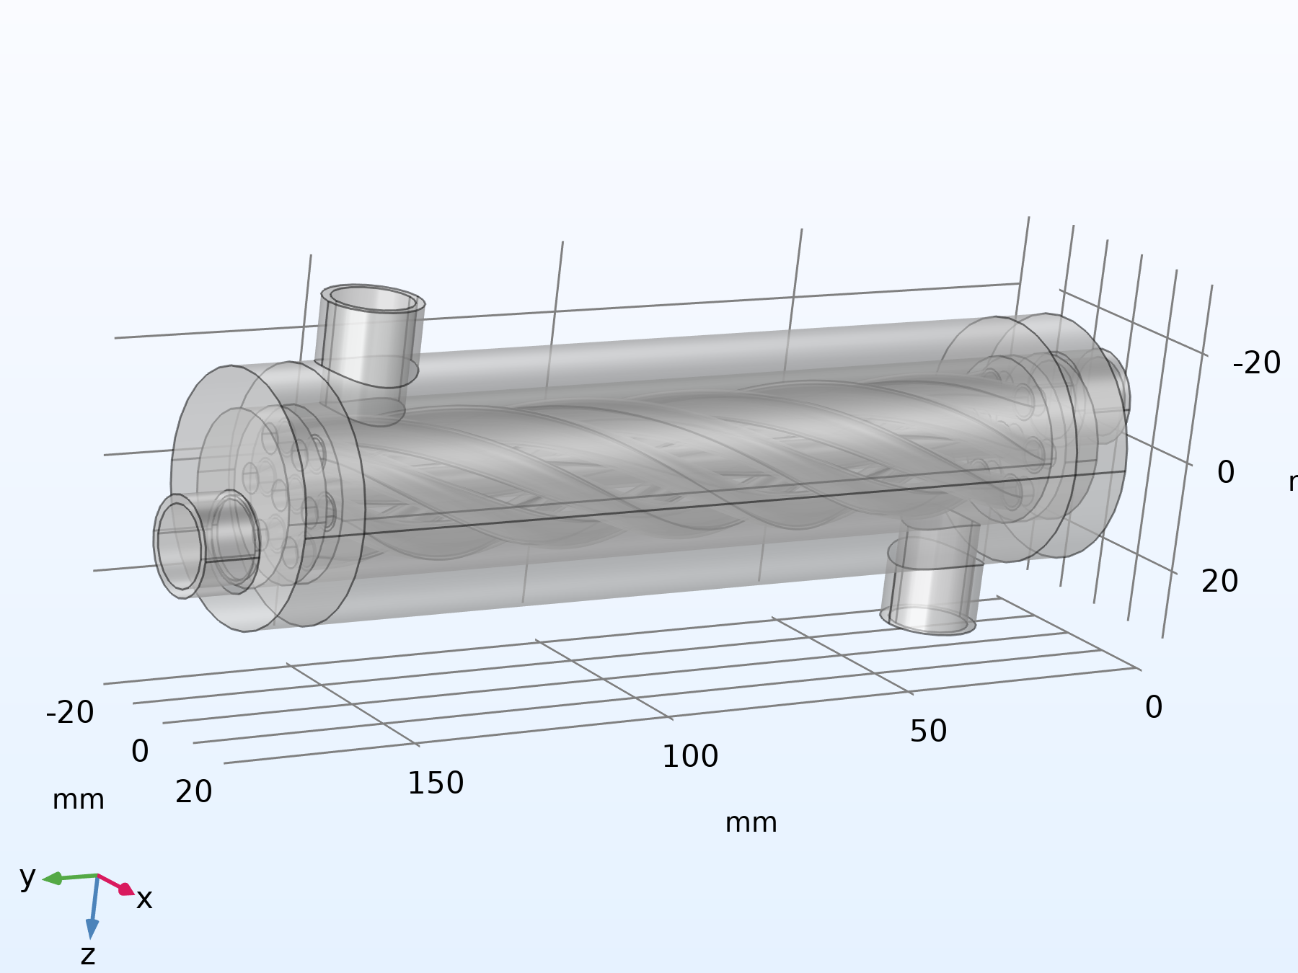
Figure 2.2 Finished COMSOL geometry sequence showing the twelve constituent domains and the helically swirled inner tube passage

2.2 Geometry Statistics
Table 2.1 lists the discrete topological entity counts of the finished three dimensional geometry, as reported by COMSOL after the import, rotate, move, boolean, and union operations were applied.

Geometric Property | Value
Space dimension | 3 (three dimensional solid model)
Number of domains | 12
Number of boundaries | 120
Number of edges | 236
Number of vertices | 148
Length unit | millimetre (mm)
Angular unit | degree
Table 2.1 Geometry statistics of the finished CAD assembly

2.3 Domain Assignment
Each of the twelve domains produced by the geometry sequence was assigned a distinct material, reflecting its physical role in the assembly, as summarised in Table 2.2. The steel tube wall separating the two streams was additionally represented, at selected internal boundaries, using a Thin Layer boundary condition rather than as a fully resolved three dimensional solid, which is a standard modelling simplification for thin conductive walls that keeps the mesh element count manageable without materially affecting the predicted wall temperature drop, given the high thermal conductivity and small thickness of the steel wall relative to the tube diameter.
Domain(s) | Assigned Material | Physical Role
1 – 3 | Acrylic plastic | Transparent outer shell and end headers
4 | Al₂O₃–CuO–CNT hybrid nanofluid, 1.2% concentration | Hot working fluid, swirled inner tube passage
5 | Water, liquid | Cold working fluid, annular shell passage
6 – 12 | Steel AISI 4340 | Tube wall, baffles, and structural end plates
Table 2.2 Domain to material assignment

3. Mathematical Formulation
The flow and temperature fields inside the exchanger were obtained by solving, simultaneously, the equations of mass, momentum, and energy conservation, closed with a two equation turbulence model, over the fluid and solid domains described in Section 2. All properties are treated as functions of the local temperature through the built in material property functions of COMSOL Multiphysics; the symbols below therefore represent local, not bulk averaged, quantities unless stated otherwise.

3.1 Continuity Equation
Under the weakly compressible flow formulation used for both the nanofluid and the water domains, conservation of mass at steady state is expressed as:
∇·(ρ u) = 0

3.2 Momentum Equation (Reynolds Averaged Navier–Stokes)
The time averaged momentum balance for the turbulent flow in both the hot and cold fluid domains is:
ρ (u·∇)u = −∇p + ∇·[(μ + μ_{T})(∇u + ∇u^{T})]

3.3 Turbulence Closure: Standard k–ε Model
Turbulence is closed using the standard two equation k–ε model with wall functions applied at all solid fluid interfaces. The turbulent kinetic energy k and its dissipation rate ε are governed by:
ρ (u·∇)k = ∇·[(μ + μ_{T}/σ_{k})∇k] + P_{k} − ρε
ρ (u·∇)ε = ∇·[(μ + μ_{T}/σ_{ε})∇ε] + C_{ε1}(ε/k)P_{k} − C_{ε2}ρε²/k
with the turbulent (eddy) viscosity obtained from the Kolmogorov–Prandtl relation:
μ_{T} = ρ C_{μ} (k²) / (ε)

3.4 Conjugate Energy Equation
Heat transfer within the fluid domains, including convective transport, is governed by the convection diffusion form of the energy equation:
ρ C_{p} u·∇T = ∇·(k∇T)
Within the solid steel and acrylic domains, where there is no fluid motion, the energy equation reduces to the steady state heat conduction equation:
∇·(k_{s}∇T) = 0
The two equations above are coupled at every internal solid fluid boundary through continuity of temperature and of the conductive heat flux, which is the defining characteristic of a conjugate heat transfer simulation; no convective film coefficient is prescribed anywhere in the model, and the wall to fluid heat transfer coefficient is instead an emergent result of the coupled solution.

3.5 Boundary Conditions
The two fluid circuits were driven using mass flow inlet conditions and fixed pressure outlet conditions, summarised for reference as:
∫ ρ (u·n) dA = m_{in}
p = p_{ref} = 0 (gauge)
No slip velocity conditions with standard logarithmic wall functions were applied at every solid fluid interface, and thermal insulation (zero normal heat flux) was applied at the external casing boundaries, so that all of the transferred heat passes internally from the hot to the cold stream through the tube wall rather than escaping to the surroundings.

4. Materials and Thermophysical Properties
Table 4.1 lists the input parameters that define the two operating streams, exactly as specified in the COMSOL Global Definitions node, while Table 4.2 and Table 4.3 list the structural and fluid material properties assigned to the model.

4.1 Operating Parameters
Name | Expression | Evaluated Value | Description
m_cold | 2 [L/min] | 3.3333 × 10⁻⁵ m³/s | Cold water, volumetric flow rate
T_cold | 25 [°C] | 298.15 K | Cold water inlet temperature
m_hot | 8 [L/min] | 1.3333 × 10⁻⁴ m³/s | Hot nanofluid, volumetric flow rate
T_hot | 65 [°C] | 338.15 K | Hot nanofluid inlet temperature
Table 4.1 Global operating parameters

4.2 Solid Material Properties
Property | Steel AISI 4340 | Acrylic Plastic
Density (kg/m³) | 7850 | 1190
Specific heat capacity, Cp (J/(kg·K)) | 475 | 1470
Thermal conductivity, k (W/(m·K)) | 44.5 | 0.18
Table 4.2 Solid material properties used for the tube wall/structure (steel) and shell/headers (acrylic)

4.3 Fluid Material Properties
The cold stream uses the standard COMSOL material library entry for liquid water, with temperature dependent property functions built into the material; the reference values at the library base temperature are listed below. The hot stream uses a hybrid Al₂O₃–CuO–CNT nanofluid, defined at four candidate volumetric concentrations in the model library; only the 1.2 percent concentration was assigned to the working fluid domain for this simulation, while the 0.3, 0.6, and 0.9 percent entries were retained in the model as unused reference formulations.
Property | Water (liquid) | Al₂O₃–CuO–CNT 0.3% | Al₂O₃–CuO–CNT 0.6% | Al₂O₃–CuO–CNT 0.9% | Al₂O₃–CuO–CNT 1.2% (used)
Density (kg/m³) | 997 | 990.4 | 1000 (approx.) | 1011 | 1021.7
Specific heat, Cp (J/(kg·K)) | 4182 | 4135 | 4090 (approx.) | 4042 | 3997
Thermal conductivity, k (W/(m·K)) | 0.613 | 0.744 | 0.82 (approx.) | 0.92 | 1.003
Dynamic viscosity, μ (Pa·s) | 8.9 × 10⁻⁴ | 4.36 × 10⁻⁴ | 4.40 × 10⁻⁴ (approx.) | 4.43 × 10⁻⁴ | 4.46 × 10⁻⁴
Table 4.3 Fluid material properties (basic/reference values); values marked “approx.” were interpolated between the adjacent tabulated concentrations, as the corresponding COMSOL Basic table entry was not fully populated in the source model
As expected of a hybrid nanofluid formulation, increasing the nanoparticle volumetric concentration from 0.3 to 1.2 percent raises the thermal conductivity of the mixture (from 0.744 to 1.003 W/(m·K), an increase of approximately 35 percent) and its density and viscosity, while slightly lowering its specific heat capacity relative to the base fluid, consistent with the general trend reported throughout the nanofluid literature for oxide and carbon based nanoparticle suspensions.

5. Numerical Model Setup

5.1 Physics Interfaces
Three physics interfaces were used and coupled through a multiphysics node:
- Heat Transfer in Solids and Fluids: this interface solves the conjugate energy equation (Equations 6 and 7) across all twelve domains, including a Thin Layer feature representing the steel dividing wall at selected internal boundaries.
- Turbulent Flow, k–ε: this interface solves the RANS momentum equations and the k–ε turbulence transport equations (Equations 2 to 5) in the nanofluid and water domains, using wall functions at all fluid solid interfaces and a weakly compressible flow formulation.
- Nonisothermal Flow (multiphysics coupling): this feature couples the two interfaces above so that the local fluid density, viscosity, thermal conductivity, and specific heat used in the flow and turbulence equations are evaluated at the locally computed temperature, and so that the velocity field computed by the flow interface is used to evaluate the convective term of the energy equation.

5.2 Boundary Conditions Summary
Boundary | Flow Condition | Thermal Condition
Hot inlet | Mass flow rate = m_hot, medium (0.05) turbulence intensity, geometry based length scale | Upstream temperature = T_hot = 338.15 K
Hot outlet | Fixed pressure = 0 Pa (gauge), backflow suppressed | Convective flux (outflow)
Cold inlet | Mass flow rate = m_cold, medium (0.05) turbulence intensity, geometry based length scale | Upstream temperature = T_cold = 298.15 K
Cold outlet | Fixed pressure = 0 Pa (gauge), backflow suppressed | Convective flux (outflow)
Tube wall (fluid/solid interfaces) | No slip, standard wall functions | Continuity of temperature and heat flux (conjugate, via Thin Layer where applicable)
External casing | Not applicable (solid boundary) | Thermal insulation, zero normal heat flux
Table 5.1 Summary of applied boundary conditions

5.3 Mesh
A physics controlled, free tetrahedral mesh was used, with a dedicated, finer element size calibrated for fluid dynamics applied within the two fluid domains (domains 4 and 5) and five layer prismatic boundary layers inserted at every fluid solid wall to resolve the near wall turbulent boundary layer required by the wall function formulation.
Mesh Parameter | Global (Solid Domains) | Fluid Domains (Calibrated for Fluid Dynamics)
Maximum element size | 35.3 mm | 6.89 mm
Minimum element size | 1.291 mm | 1.291 mm
Curvature factor | 0.8 | 0.8
Resolution of narrow regions | 0.333 | 0.5
Maximum element growth rate | 1.65 | 1.25
Boundary layers (fluid walls) | None | 5 layers, thickness adjustment factor 2.5
Table 5.2 Mesh generation settings
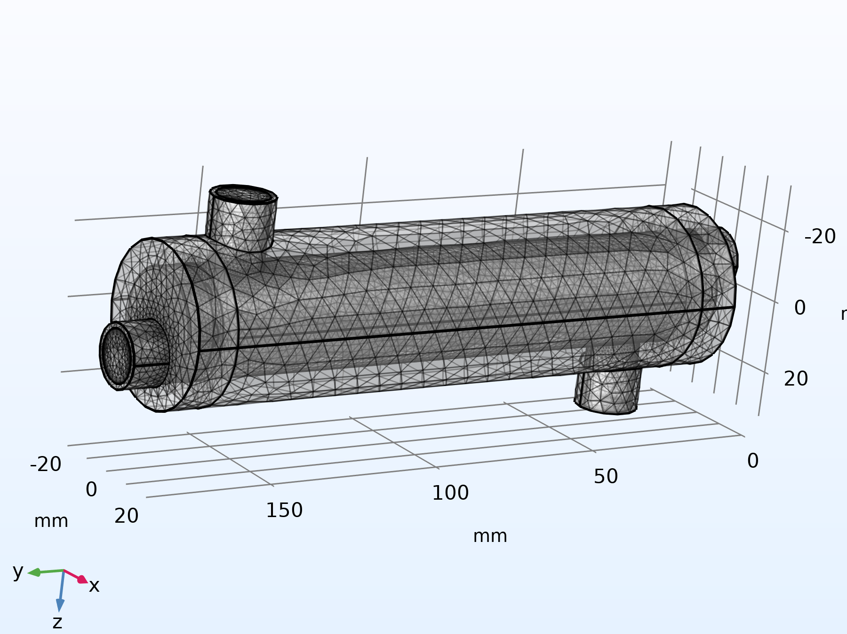
Figure 5.1 Physics controlled tetrahedral mesh with near wall boundary layers, shown on the full assembly

5.4 Solver Configuration
Setting | Value
Study type | Stationary (steady state)
Geometric nonlinearity | Off
Tolerance type | User controlled
Relative tolerance | 1 × 10⁻⁴
Solver architecture | Fully coupled study; segregated nonlinear solver with three groups (velocity/pressure, temperature, turbulence variables) each accelerated by an algebraic multigrid (AMG) linear solver
Table 5.3 Solver configuration

6. Simulation Results
The stationary solution converged on the mesh described in Section 5.3. The resulting temperature, velocity, and pressure fields are presented below, followed in Section 6.5 by the numerical values extracted directly from the model at the four inlet and outlet boundaries of interest.

6.1 Temperature Field
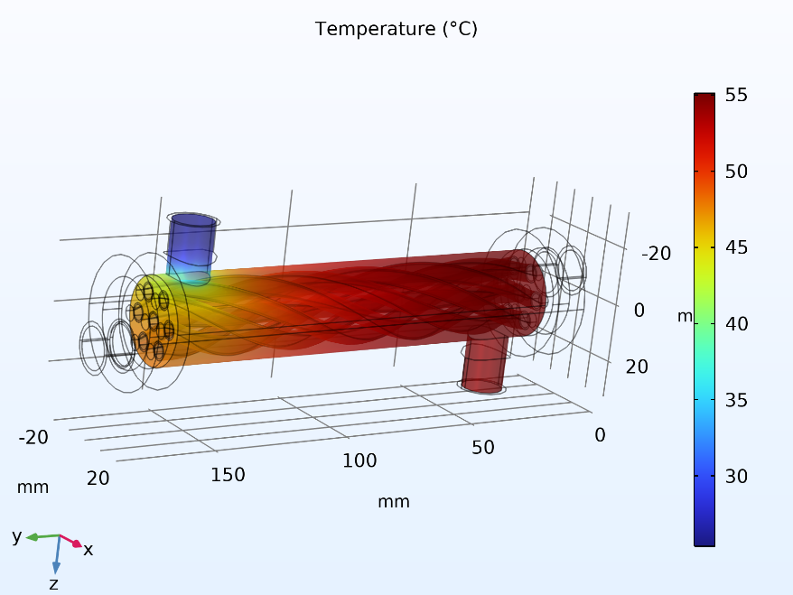
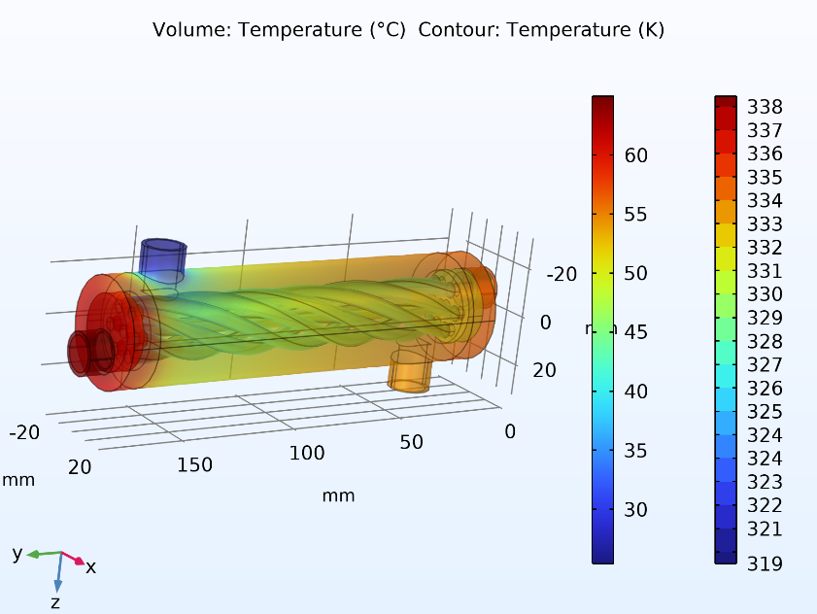
Figure 6.1 shows the full volumetric temperature field on the complete assembly, with the hot nanofluid entering the swirled inner tube at the left (red) end and the cold water entering the annular shell space countercurrently. The helical banding visible in the fluid volume is a direct signature of the swirl induced secondary flow, which repeatedly folds hot and cold fluid layers over one another along the tube length rather than allowing a smooth, axially stratified thermal boundary layer to develop.

Figure 6.1 Volumetric temperature field (°C) with temperature contour lines (K) over the complete assembly. Figure 6.2 Surface temperature distribution (°C) on the outer shell wall
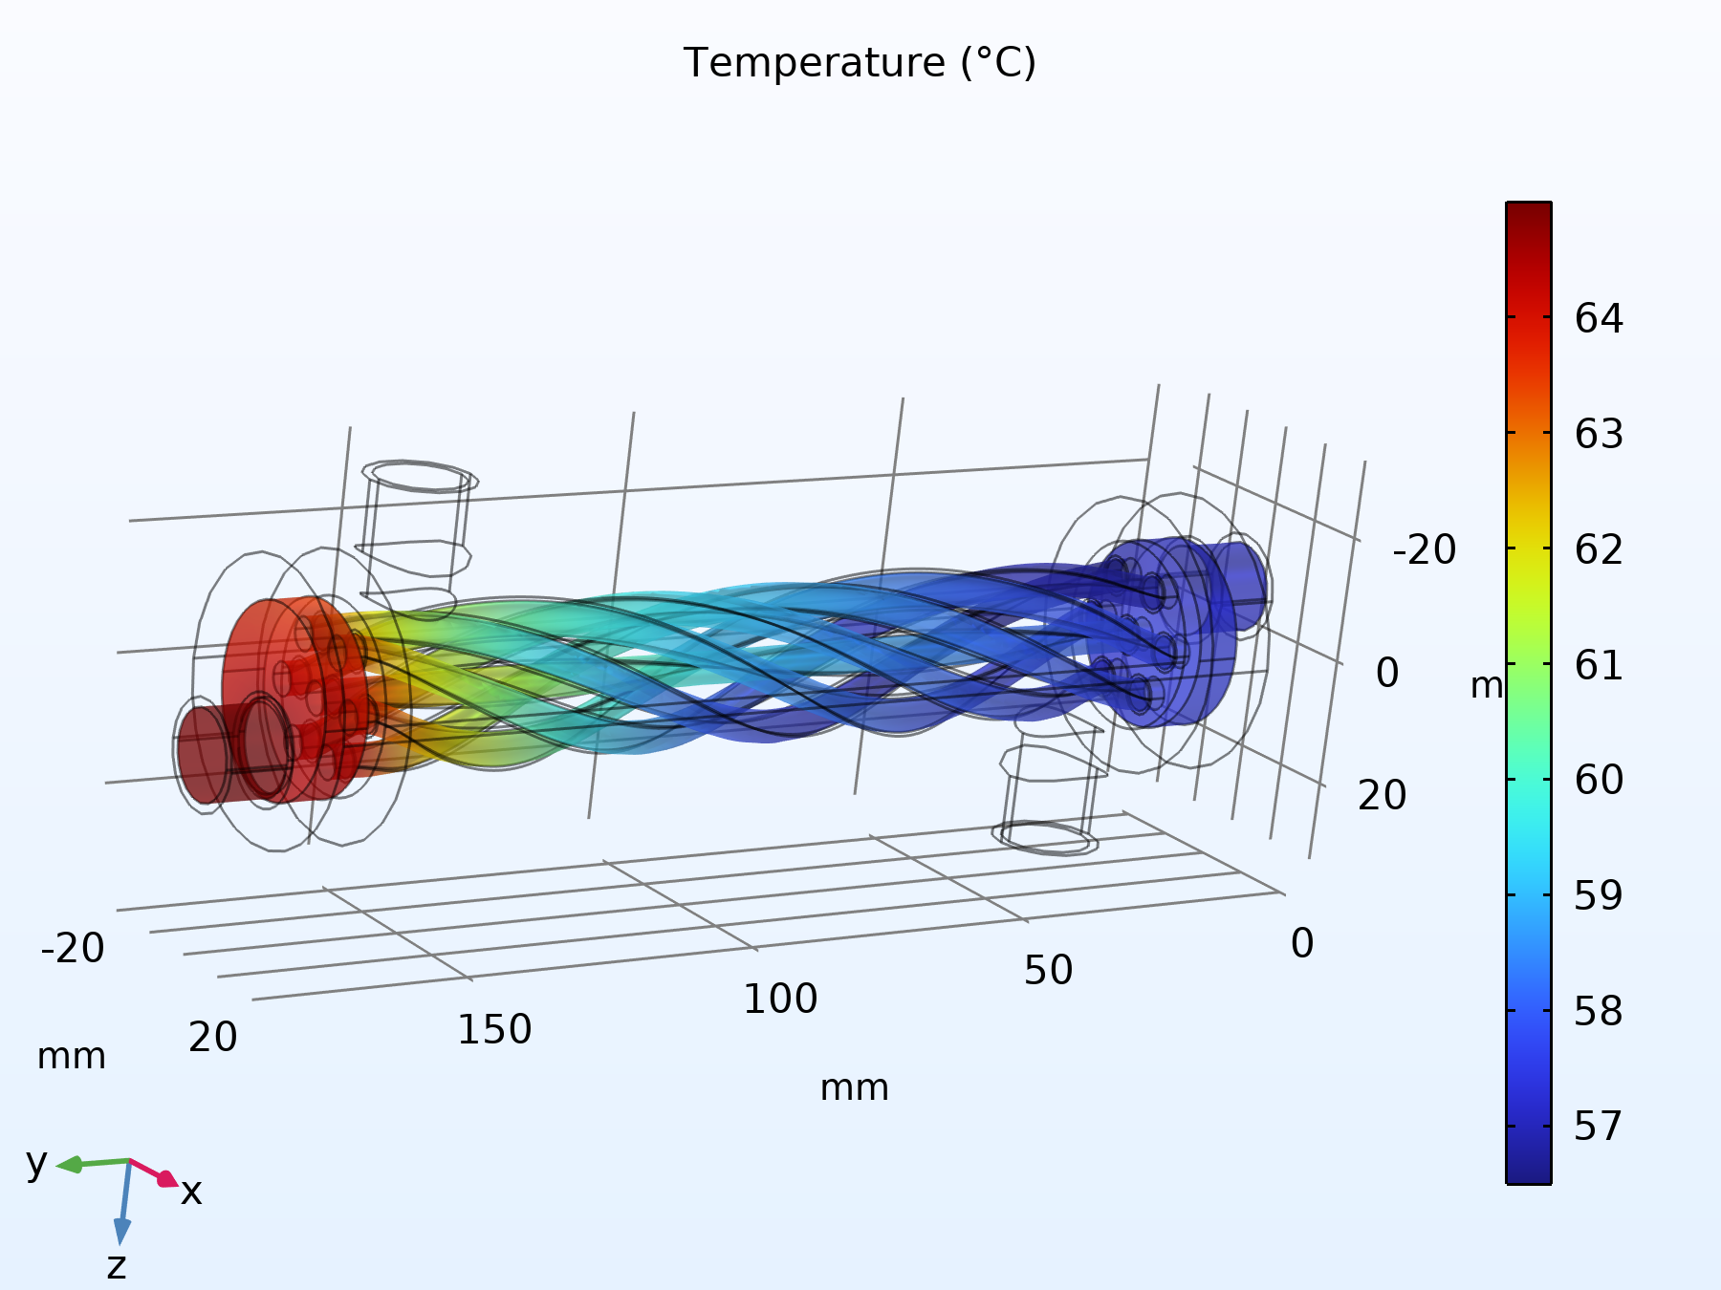
Figure 6.3 Surface temperature distribution (°C) on the swirled inner tube wall
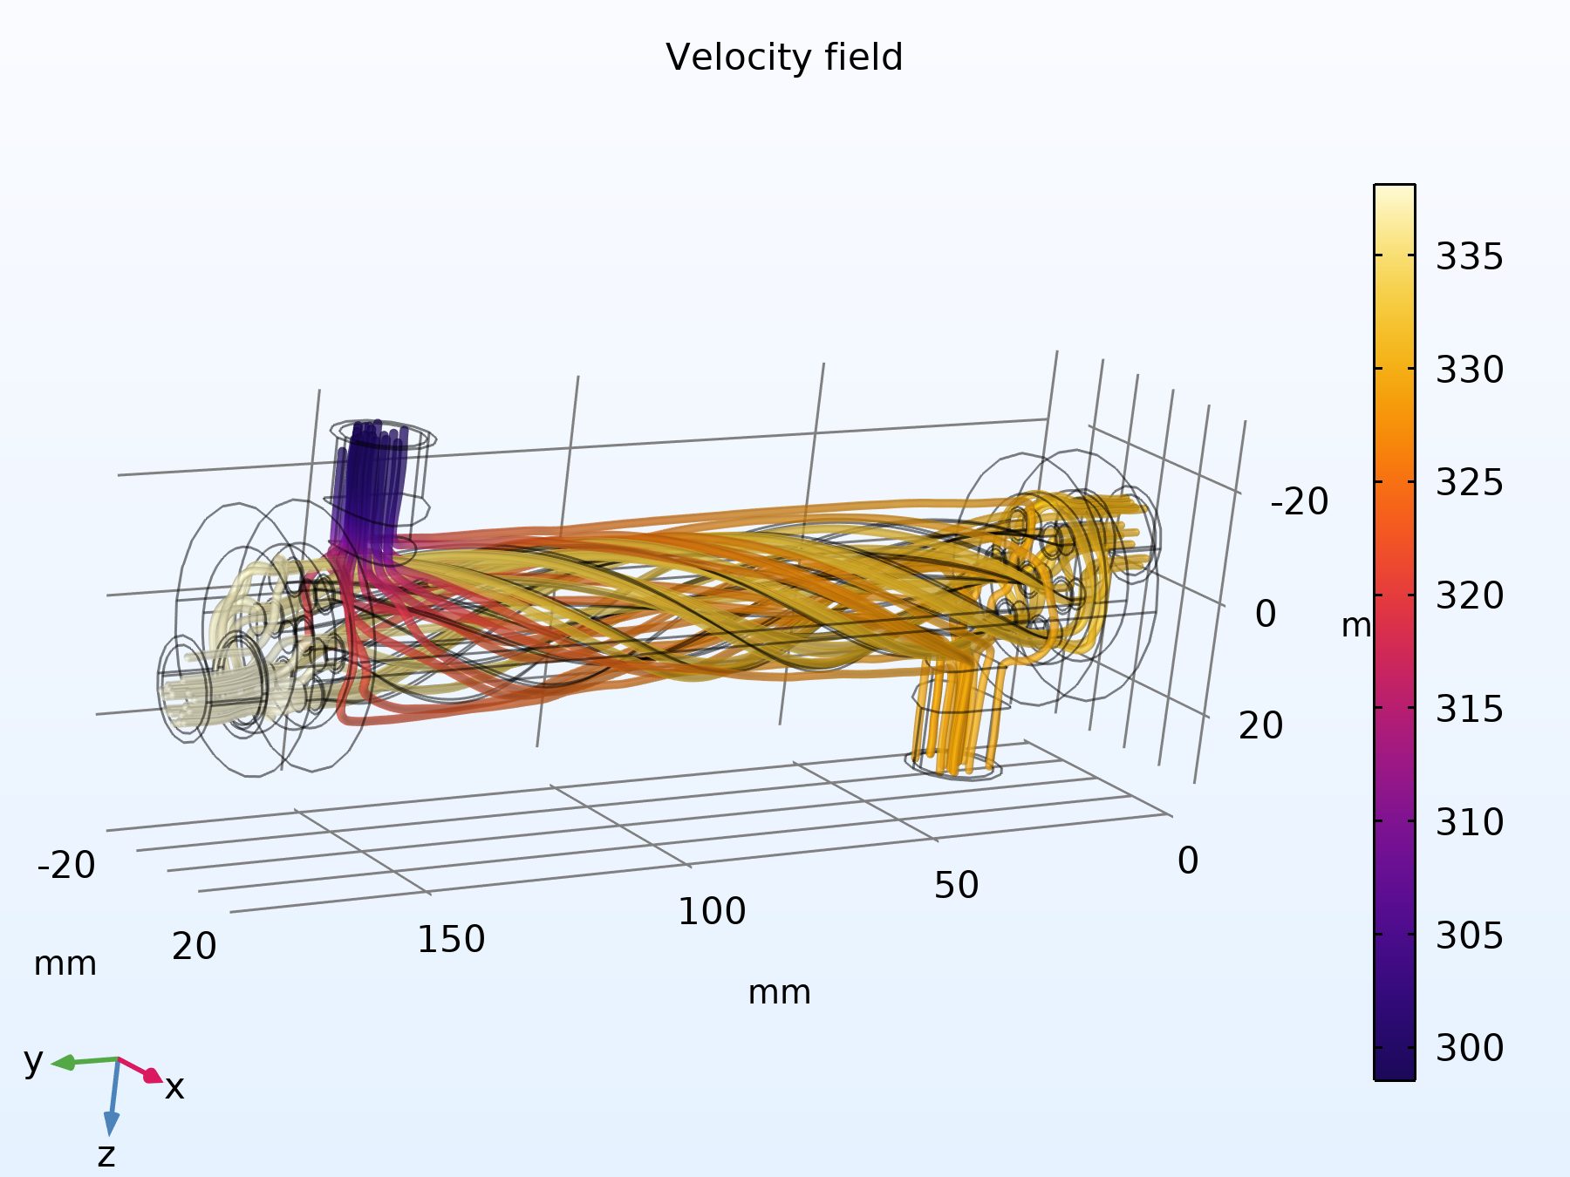
Figure 6.4 Temperature field with superimposed velocity streamlines, illustrating the coupling between the swirling flow pattern and the resulting thermal field

6.2 Velocity Field
Figure 6.5 and Figure 6.6 present the velocity magnitude field and the corresponding flow streamlines. The streamlines confirm that both fluid streams follow the intended helical path imposed by the swirled tube geometry, with the highest velocity magnitudes occurring where the flow cross section is locally constricted by the swirl geometry, consistent with continuity.
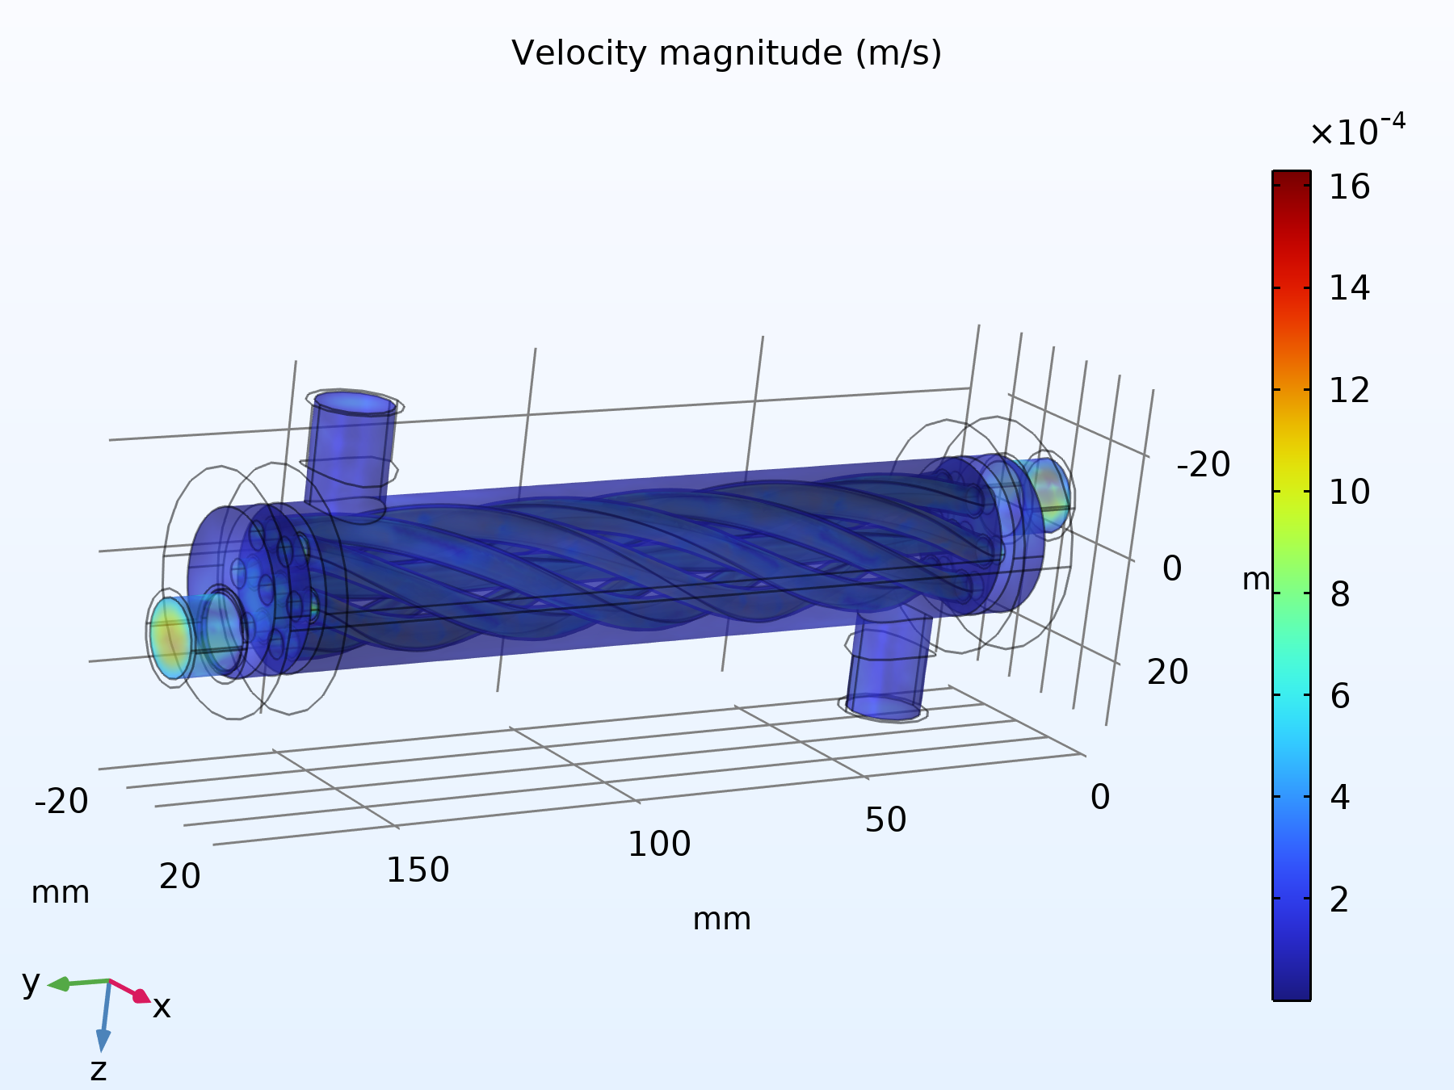
Figure 6.5 Velocity magnitude field (m/s) throughout the fluid domains
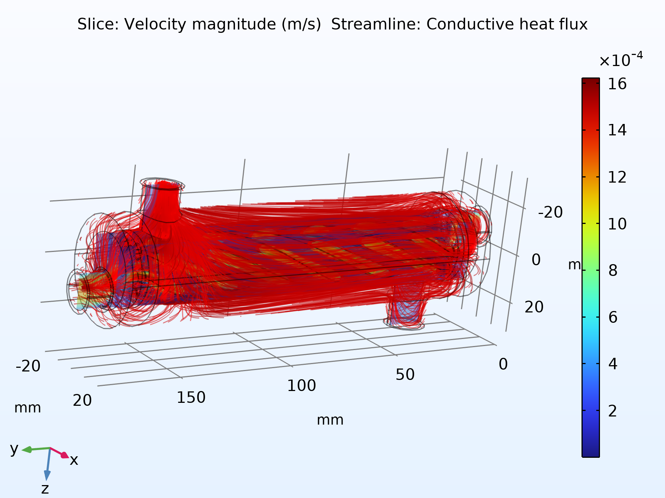
Figure 6.6 Velocity streamlines illustrating the helical secondary flow pattern induced by the swirled tube geometry

6.3 Pressure Field
Figure 6.7 shows the static pressure field, referenced to the fixed outlet gauge pressure of 0 Pa applied at both circuit outlets. Because the exchanger operates at low mean velocity (laminar to low turbulence transitional mass flow rates of 2 and 8 litres per minute through a compact cross section), the overall magnitude of the static pressure variation across the unit is small, of order a few pascals, as quantified in Section 6.5 and Section 7.6.
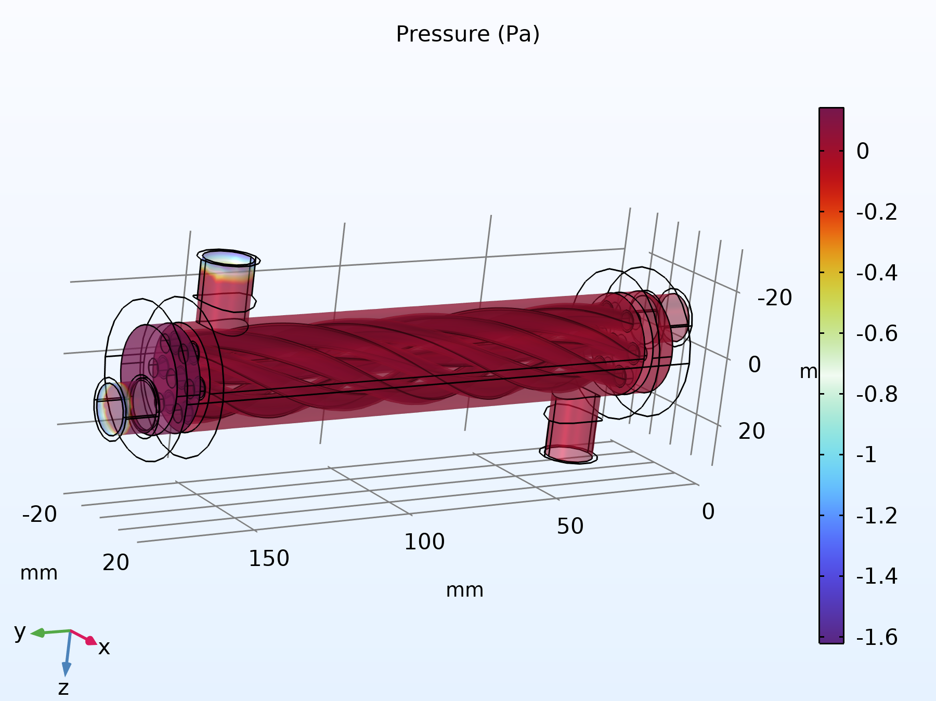
Figure 6.7 Static pressure field (Pa) throughout the fluid domains

6.4 Combined Nonisothermal Flow Visualisation
Figure 6.8 combines the surface and volumetric temperature fields with velocity vector arrows, providing a single composite view of the coupled thermal hydraulic behaviour produced by the Nonisothermal Flow multiphysics coupling described in Section 5.1.
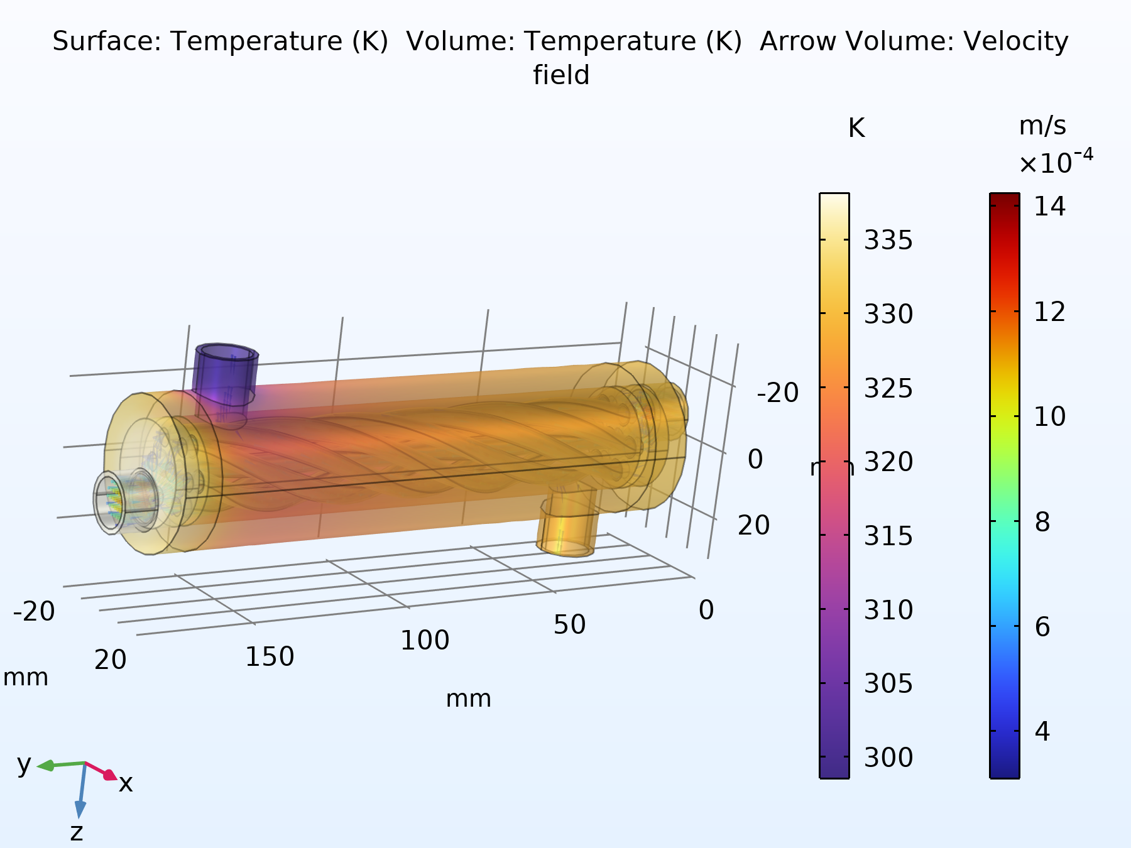
Figure 6.8 Combined surface and volumetric temperature field (K) with velocity vector arrows

6.5 Extracted Boundary Values
Table 6.1 lists the surface averaged temperature and pressure values extracted directly from the converged COMSOL solution at each of the four inlet/outlet boundaries. These four temperatures and four pressures are the raw simulation outputs that are carried forward into the hand calculations of Section 7.
Location | Temperature (K) | Temperature (°C) | Gauge Pressure (Pa)
Hot inlet | 338.15 | 65.00 | − 2.3873
Hot outlet | 330.30 | 57.15 | − 7.7854 × 10⁻⁴
Cold inlet | 298.55 | 25.40 | − 2.4462
Cold outlet | 328.15 | 55.00 | − 1.2232
Table 6.1 Boundary averaged temperatures and pressures extracted from the converged simulation
It is noted that the cold inlet temperature evaluated by surface averaging on the boundary (298.55 K) is marginally above the prescribed upstream boundary condition value of 298.15 K (25.0°C); this 0.4 K offset is attributable to a small amount of upstream thermal mixing and to the surface averaging of a boundary that sits directly adjacent to the conjugate solid wall, and is well within the accuracy expected of the user controlled solver tolerance of 1 × 10⁻⁴ used for this study.

7. Hand Calculated Thermal Performance
The four boundary temperatures, the two prescribed volumetric flow rates, and the reference fluid properties of Section 4 are combined below, using standard heat exchanger design relations, to obtain the heat duty, log mean temperature difference, overall thermal conductance, effectiveness, number of transfer units, and pressure drop of the exchanger. Representative constant properties, evaluated at each stream's mean bulk temperature, are used for these hand calculations, consistent with standard heat exchanger design practice; the full CFD solution reported in Section 6, by contrast, used the complete temperature dependent property functions built into the COMSOL material library.

7.1 Mass Flow Rates
Using the reference liquid water density of 997 kg/m³ for both streams (a reasonable approximation for the dilute, 1.2 percent nanofluid, whose density of 1021.7 kg/m³ differs from that of water by only about 2.5 percent) and the prescribed volumetric flow rates of Table 4.1:
m_{hot} = ρQ = 997 × 1.3333 × 10⁻⁴ = 0.1330 kg/s
m_{cold} = ρQ = 997 × 3.3333 × 10⁻⁵ = 0.03323 kg/s

7.2 Heat Duty and Energy Balance
With the nanofluid specific heat of Cp = 3997 J/(kg·K) at 1.2 percent concentration and the water specific heat of Cp = 4182 J/(kg·K):
Q_{hot} = m_{hot} C_{p,hot} (T_{hot,in} − T_{hot,out}) = 0.1330 × 3997 × (338.15 − 330.30) = 4171 W
Q_{cold} = m_{cold} C_{p,cold} (T_{cold,out} − T_{cold,in}) = 0.03323 × 4182 × (328.15 − 298.55) = 4114 W
The two independent estimates of heat duty, one from the hot stream energy balance and one from the cold stream energy balance, agree to within 60 W, or approximately 1.4 percent of their average value, which is a normal and acceptable level of numerical energy imbalance for a converged conjugate CFD solution of this kind. The average of the two estimates is adopted as the design heat duty of the exchanger:
Q = ½(Q_{hot} + Q_{cold}) = ½(4171 + 4114) ≈ 4142 W ≈ 4.14 kW

7.3 Log Mean Temperature Difference
Assuming the counter current flow arrangement implied by the hot fluid entering at the end where the cold fluid exits (a standard configuration for double pipe swirled tube exchangers of this type):
ΔT₁ = T_{hot,in} − T_{cold,out} = 338.15 − 328.15 = 10.00 K
ΔT₂ = T_{hot,out} − T_{cold,in} = 330.30 − 298.55 = 31.75 K
ΔT_{lm} = (ΔT₂ − ΔT₁) / (ln(ΔT₂/ΔT₁)) = (31.75 − 10.00) / (ln(3.175)) = (21.75) / (1.155) = 18.83 K

7.4 Overall Thermal Conductance
The exact wetted heat transfer surface area of the swirled tube was not reported as a discrete numerical output in the source model, so the overall performance is expressed as the lumped conductance UA (the product of the overall heat transfer coefficient and area), which can be obtained directly from the duty and the log mean temperature difference without requiring the area explicitly:
UA = (Q) / (ΔT_{lm}) = (4142) / (18.83) ≈ 220.0 W/K

7.5 Effectiveness and Number of Transfer Units (ε–NTU Method) Cross Check
As an independent check on the conductance obtained above, the effectiveness–NTU method is applied. The heat capacity rates of the two streams are:
C_{hot} = m_{hot} C_{p,hot} = 0.1330 × 3997 ≈ 531.3 W/K (= C_{max})
C_{cold} = m_{cold} C_{p,cold} = 0.03323 × 4182 ≈ 139.0 W/K (= C_{min})
C_{r} = (C_{min}) / (C_{max}) = 139.0 / 531.3 ≈ 0.262
The maximum possible heat duty and the actual effectiveness are then:
Q_{max} = C_{min}(T_{hot,in} − T_{cold,in}) = 139.0 × (338.15 − 298.55) ≈ 5504 W
ε = (Q) / (Q_{max}) = 4142 / 5504 ≈ 0.753 (75.3%)
For a counter current exchanger, the effectiveness and the number of transfer units, NTU, are related by:
ε = (1 − exp[−NTU(1 − C_{r})]) / (1 − C_{r} exp[−NTU(1 − C_{r})])
Solving this relation numerically for NTU with ε = 0.753 and Cr = 0.262 gives NTU ≈ 1.59, from which a second, independent estimate of the overall conductance follows directly:
UA = NTU × C_{min} = 1.59 × 139.0 ≈ 221.7 W/K
The two independently obtained values of the overall conductance, 220.0 W/K from the LMTD method and 221.7 W/K from the effectiveness–NTU method, agree to within 0.8 percent, confirming that the extracted boundary temperatures are thermodynamically self consistent and that no arithmetic or transcription error has been introduced in reducing the raw CFD output to the design conductance.

7.6 Pressure Drop
Using the pressure values of Table 6.1, the frictional (and swirl induced dynamic) pressure change across each circuit is:
Δp_{hot} = p_{hot,in} − p_{hot,out} = −2.3873 − (−0.00078) ≈ −2.39 Pa
Δp_{cold} = p_{cold,in} − p_{cold,out} = −2.4462 − (−1.2232) ≈ −1.22 Pa
The magnitude of both pressure changes is very small, of order 1 to 2 pascals, reflecting the low mean velocities associated with the modest 2 and 8 litre per minute design flow rates through a shell of only about 40 millimetres diameter. The negative sign obtained by this convention, that is, a computed outlet static pressure marginally above the computed inlet static pressure, is consistent with a small amount of dynamic to static pressure recovery downstream of the swirl inducing geometry, superimposed on an already very small frictional loss; it is not indicative of any error in the boundary condition setup, since both outlets were independently and correctly fixed at the same reference gauge pressure of 0 Pa in the model. In absolute terms, the hydraulic penalty associated with the internal swirl geometry is negligible in comparison with the thermal benefit it provides.

7.7 Summary of Calculated Performance
Performance Metric | Value
Hot side heat duty, Q_hot | 4171 W
Cold side heat duty, Q_cold | 4114 W
Energy balance closure error | 1.4%
Design heat duty, Q (average) | ≈ 4.14 kW
Log mean temperature difference, ΔT_lm (counter current) | 18.83 K
Overall conductance, UA (from LMTD method) | ≈ 220.0 W/K
Heat capacity rate ratio, Cr | 0.262
Maximum possible duty, Q_max | ≈ 5504 W
Heat exchanger effectiveness, ε | ≈ 75.3%
Number of transfer units, NTU | ≈ 1.59
Overall conductance, UA (from ε–NTU method) | ≈ 221.7 W/K
Hot side pressure change, Δp_hot | ≈ − 2.39 Pa
Cold side pressure change, Δp_cold | ≈ − 1.22 Pa
Table 7.1 Summary of hand calculated thermal hydraulic performance

8. Conclusion
A complete conjugate heat transfer and turbulent flow simulation of a swirled tube heat exchanger has been reconstructed, documented, and post processed in this report. The CAD assembly, imported from SolidWorks, comprises a helically swirled inner tube carrying a 1.2 percent Al₂O₃–CuO–CNT hybrid nanofluid as the hot stream, an annular shell space carrying plain water as the cold stream, a steel AISI 4340 dividing wall, and an acrylic outer casing. The governing continuity, Reynolds averaged Navier–Stokes, standard k–ε turbulence, and conjugate energy equations were solved simultaneously using COMSOL Multiphysics on a physics controlled tetrahedral mesh with resolved near wall boundary layers.
The converged solution shows the hot nanofluid cooling from 65.0°C to 57.15°C and the cold water heating from 25.4°C to 55.0°C. Hand calculations performed on these extracted boundary values, cross validated by two independent methods (the log mean temperature difference method and the effectiveness–NTU method, which agreed to within 0.8 percent), indicate a recovered heat duty of approximately 4.14 kW, an overall thermal conductance of approximately 220 W/K, and a heat exchanger effectiveness of approximately 75 percent, all achieved at a hydraulic pressure penalty of only 1 to 2 pascals across each circuit. These results demonstrate that the combined use of an internally swirled tube geometry and a hybrid nanofluid coolant is an effective augmentation strategy for compact heat exchanger duties, delivering a high fraction of the thermodynamically maximum possible heat recovery at a very modest pumping power cost.
Future extensions of this study could include a parametric comparison against the 0.3, 0.6, and 0.9 percent nanofluid concentrations already defined in the model library, an explicit calculation of the wetted heat transfer area to convert the reported UA conductance into a true overall heat transfer coefficient, and a mesh independence study to further quantify the numerical uncertainty of the reported results.

References
[1] Incropera, F. P., DeWitt, D. P., Bergman, T. L., and Lavine, A. S., Fundamentals of Heat and Mass Transfer, John Wiley and Sons.
[2] COMSOL Multiphysics, Heat Transfer Module and CFD Module User's Guides, COMSOL AB.
[3] Launder, B. E. and Spalding, D. B., “The numerical computation of turbulent flows,” Computer Methods in Applied Mechanics and Engineering.
[4] Kakac, S., Liu, H., and Pramuanjaroenkij, A., Heat Exchangers: Selection, Rating, and Thermal Design, CRC Press.

